**PUP CARE**

**MINI PROJECT REPORT**

**18CSC311J – WEB DESIGN AND DEVELOPMENT**

**LABORATORY**

**(2018 Regulation)**

**III Year/ VI Semester**

**Academic Year: 2022 -2023**

By

**D.BHARGAV-RA2010028010069**

Under the guidance of

**Dr. K. Deepa Thilak**

**Assistant Professor**

**Department of Networking and Communications**



**DEPARTMENT OF NETWORKING AND COMMUNICATIONS**

**FACULTY OF ENGINEERING AND TECHNOLOGY**

**SRM INSTITUTE OF SCIENCE AND TECHNOLOGY**

**Kattankulathur, Kancheepuram**

**MAY 2023**

**BONAFIDE**

Certified that this Mini project report titled “PUP CARE” for the course **18CSC311J – WEB DESIGN AND DEVELOPMENT LABORATORY** is the bonafide work of **D.BHARGAV-RA2010028010069** who undertook the task of completing the project within the allotted time.

**Signature** **Signature**

Dr. K. Deepa Thilak Dr. Annapurani Panaiyappan K

**Course Faculty**  **Head of the Department**

Assistant Professor Professor

Department of NWC Department of NWC

**Abstract**

This website is dedicated to providing comprehensive information and resources for pet owners to help them take care of their beloved animals. From dogs and cats to birds and small animals, our website offers advice on everything from nutrition and health to training and behavior. Our team of experts provides reliable information on the latest trends and best practices for pet care, as well as tips on how to create a safe and comfortable environment for your pet. Whether you're a first-time pet owner or a seasoned pro, our website is a one-stop-shop for all your pet care needs.

**Table of Contents**

| **Chapter No.** | **Chapter Name** | **Page Number** |
| --- | --- | --- |
|  | Abstract |  |
| 1 | Introduction |  |
| 2 | System Architecture |  |
| 3 | Web Site Front End Implementation |  |
| 3.1 | Tools used |  |
| 3.2 | Web Page Design |  |
| 3.3 | Screenshots |  |
| 4 | Web Site Backend Implementation |  |
| 4.1 | Tools used |  |
| 4.2 | Code for backend |  |
| 5 | Database Design |  |
| 5.1 | Database used |  |
| 5.2 | Database schema and Tables used in the Project |  |
| 6 | Screen shots |  |
| 7 | Conclusion and Future Work |  |

**Note: All chapter contents font must be times new roman , size is 12**

**CHAPTER 1**

INTRODUCTION

1.1 Existing Web Applications

PetMD

ASPCA

Doggy Dan's Online Dog Trainer

1.2 Drawbacks of existing application

Inaccurate or outdated information: Some web pages may contain inaccurate or outdated information on pet care, which could potentially harm pets. It is important to verify the accuracy of the information before relying on it.

Overwhelming amount of information: Some web pages may provide an overwhelming amount of information on pet care, which can make it difficult for pet owners to find the information they need. It's important for web pages to organize information in a clear and concise way.

Bias or commercial interests: Some web pages may have a bias towards certain products or services, or may have commercial interests that influence the information they provide. It's important for pet owners to be aware of these potential biases.

Lack of personalization: Some web pages may provide general information on pet care, but may not take into account the unique needs of individual pets. It's important for pet owners to consult with their veterinarian or a qualified pet care professional to get personalized advice for their pet.

Limited scope: Some web pages may focus on a specific type of pet or aspect of pet care, and may not provide comprehensive information for all types of pets or pet care needs.

1.3 Project Objectives

Educate pet owners: The primary objective of many pet care web pages is to provide pet owners with accurate and reliable information on how to care for their pets. This can include information on nutrition, health, behavior, training, and more.

Promote responsible pet ownership: Many pet care web pages aim to promote responsible pet ownership by providing information on topics such as spaying/neutering, vaccination, licensing, and proper identification.

Provide resources for pet owners: Pet care web pages may offer a variety of resources for pet owners, such as product reviews, pet-friendly travel guides, directories of pet services, and more.

Raise awareness about animal welfare issues: Some pet care web pages aim to raise awareness about animal welfare issues, such as animal abuse and neglect, and provide information on how pet owners can help.

Connect pet owners with pet care professionals: Some pet care web pages offer directories of pet care professionals, such as veterinarians, pet sitters, dog trainers, and more, to help pet owners find the services they need.

Encourage pet adoption: Many pet care web pages promote pet adoption by featuring adoptable pets from local animal shelters and rescue organizations, and providing information on the adoption process.

**CHAPTER 2**

**SYSTEM ARCHITECTURE**

**2.1 System Architecture**

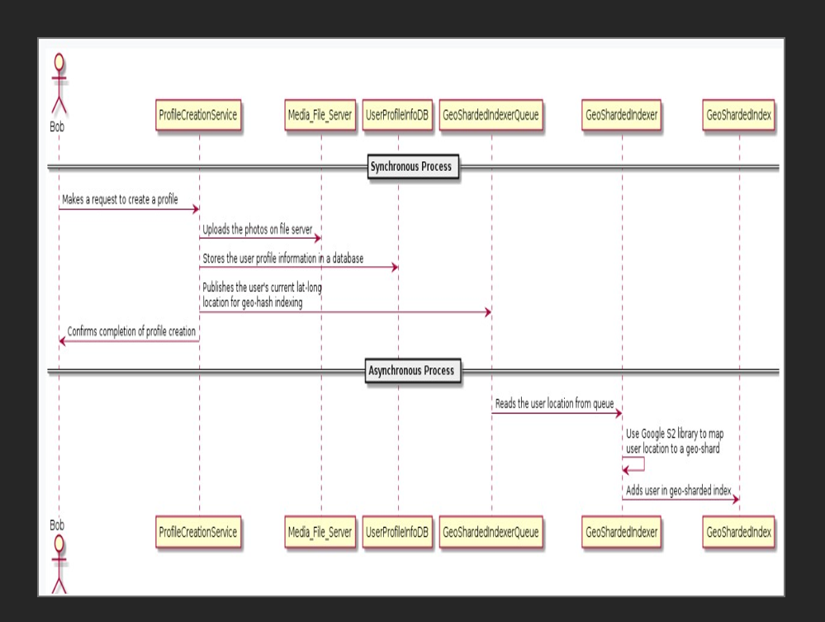

**2.2 Use Case Diagram**

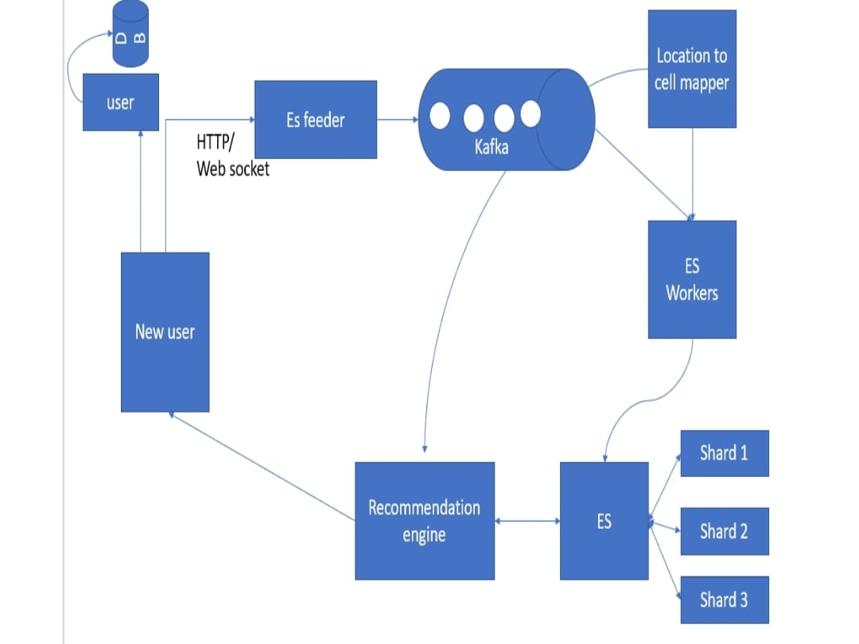

**CHAPTER 3**

**WEBSITE FRONT END IMPLEMENTATION**

**3.1 Tools used**

HTML5

CSS

JAVA Script

**3.2 Web Page Design**

**HOME PAGE.HTML:**

<!DOCTYPE html>

<html lang="en" dir="ltr">

<head>

<meta charset="UTF-8">

<meta name="viewport" content="width=device-width, initial-scale=1.0">

<!------<title> Website Layout | Pupcare</title>------>

<link rel="stylesheet" href="./Homepage.css">

<link rel="stylesheet" href="https://cdnjs.cloudflare.com/ajax/libs/font-awesome/5.15.2/css/all.min.css"/>

</head>

<body>

<nav>

<div class="menu">

<div class="logo">

<a href="#">Pupcare</a>

</div>

<ul>

<li><a href="./homepage.html">Home</a></li>

<li><a href="#">Who We</a></li>

<li><a href="#">Services</a></li>

<li><a href="#">Contact</a></li>

<li><a href="./loginform.html">Login</a></li>

<li><a href="./signin.html">signin</a></li>

</ul>

</div>

</nav>

<div class="img"></div>

<div class="center">

<div class="title">We Care Your puppy</div>

</div>

</body>

CSS:

@import url('https://fonts.googleapis.com/css2?family=Poppins:wght@200;300;400;500;600;700&display=swap');

*{

margin: 0;

padding: 0;

box-sizing: border-box;

font-family: 'Poppins',sans-serif;

}

::selection{

color: #000;

background: #fff;

}

nav{

position: fixed;

background: #1b1b1b;

width: 100%;

padding: 10px 0;

z-index: 12;

}

nav .menu{

max-width: 1250px;

margin: auto;

display: flex;

align-items: center;

justify-content: space-between;

padding: 0 20px;

}

.menu .logo a{

text-decoration: none;

color: #fff;

font-size: 35px;

font-weight: 600;

}

.menu ul{

display: inline-flex;

}

.menu ul li{

list-style: none;

margin-left: 7px;

}

.menu ul li:first-child{

margin-left: 0px;

}

.menu ul li a{

text-decoration: none;

color: #fff;

font-size: 18px;

font-weight: 500;

padding: 8px 15px;

border-radius: 5px;

transition: all 0.3s ease;

}

.menu ul li a:hover{

background: #fff;

color: black;

}

.img{

background: url('./Img.homepage.jpg')no-repeat;

width: 100%;

height: 100vh;

background-size: cover;

background-position: center;

position: relative;

}

.img::before{

content: '';

position: absolute;

height: 100%;

width: 100%;

background: rgba(0, 0, 0, 0.4);

}

.center{

position: absolute;

top: 52%;

left: 50%;

transform: translate(-50%, -50%);

width: 100%;

padding: 0 20px;

text-align: center;

}

.center .title{

color: #fff;

font-size: 55px;

font-weight: 600;

}

.center .sub_title{

color: #fff;

font-size: 52px;

font-weight: 600;

}

.center .btns{

margin-top: 20px;

}

.center .btns button{

height: 55px;

width: 170px;

border-radius: 5px;

border: none;

margin: 0 10px;

border: 2px solid white;

font-size: 20px;

font-weight: 500;

padding: 0 10px;

cursor: pointer;

outline: none;

transition: all 0.3s ease;

}

.center .btns button:first-child{

color: #fff;

background: white;

}

.btns button:first-child:hover{

background: white;

color: black;

}

.center .btns button:last-child{

background: white;

color: black;

}

a{

text-decoration: none;

}

**3.3 Screenshots**

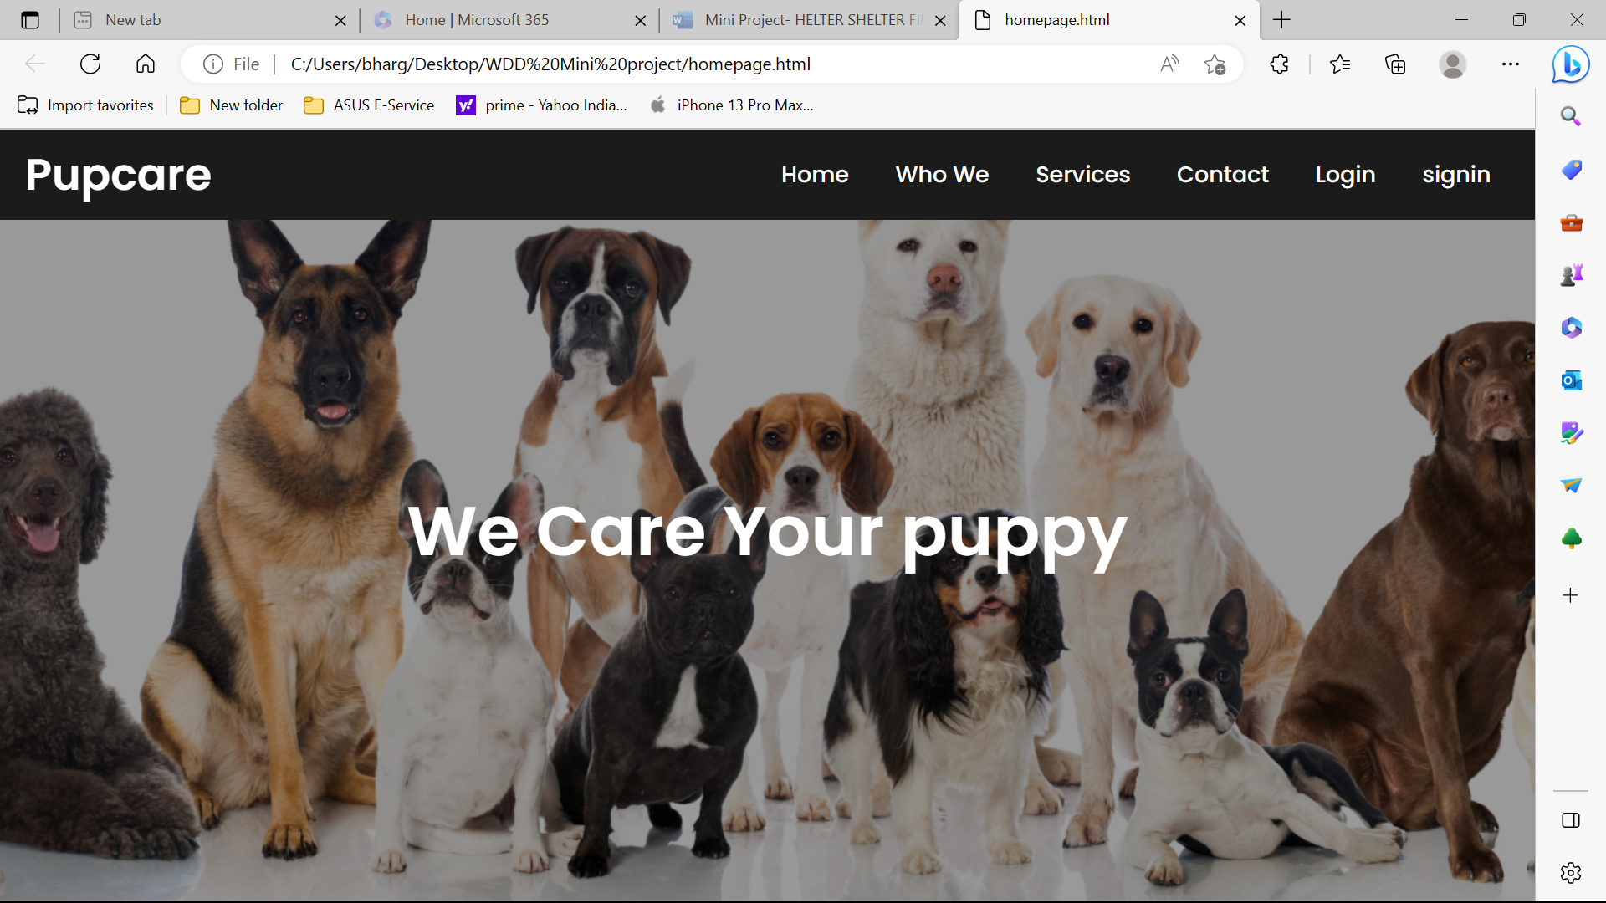

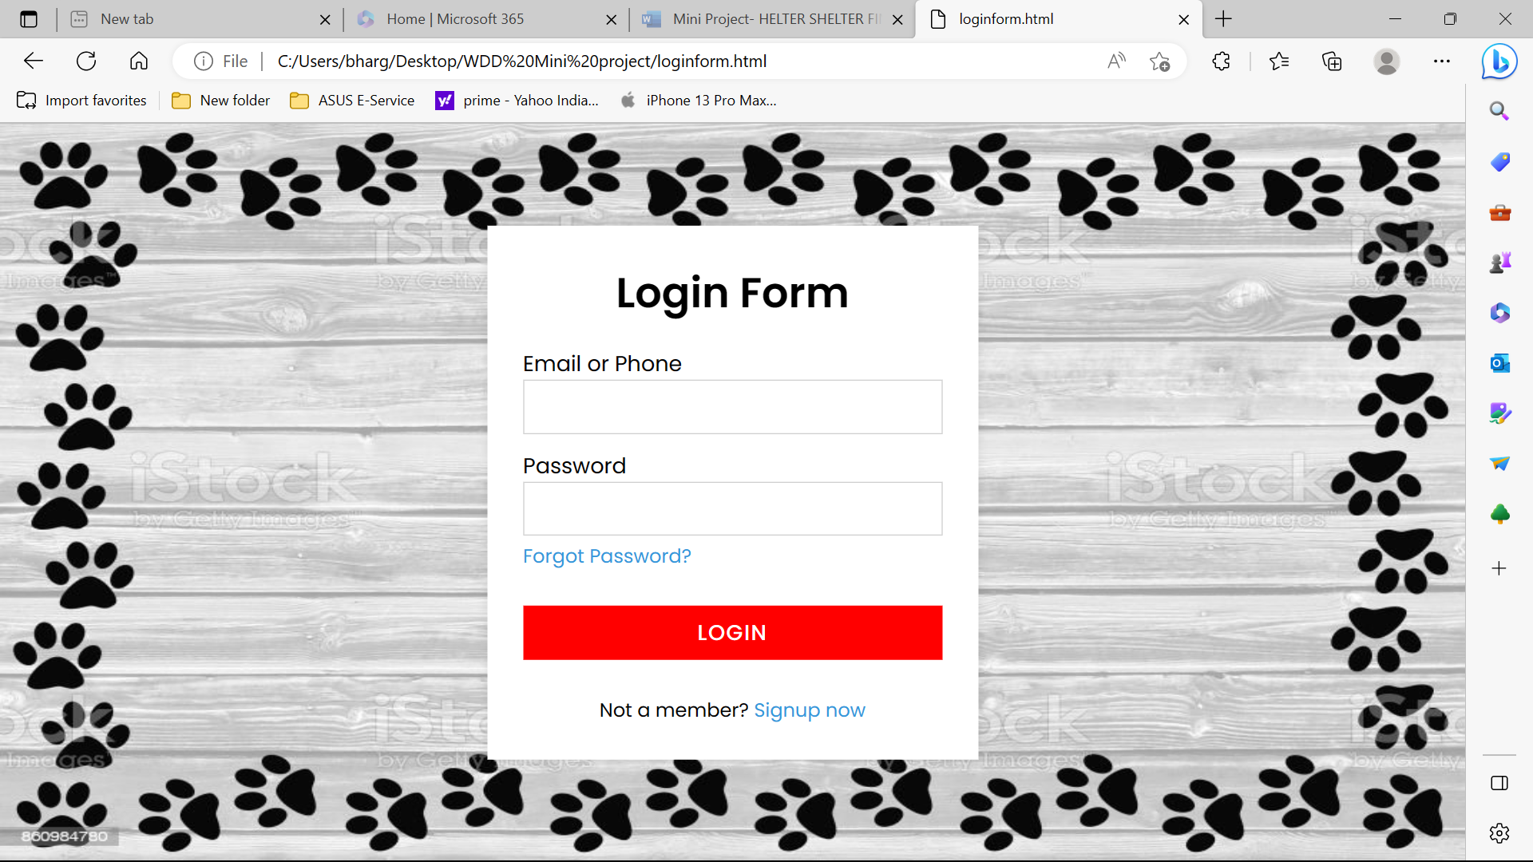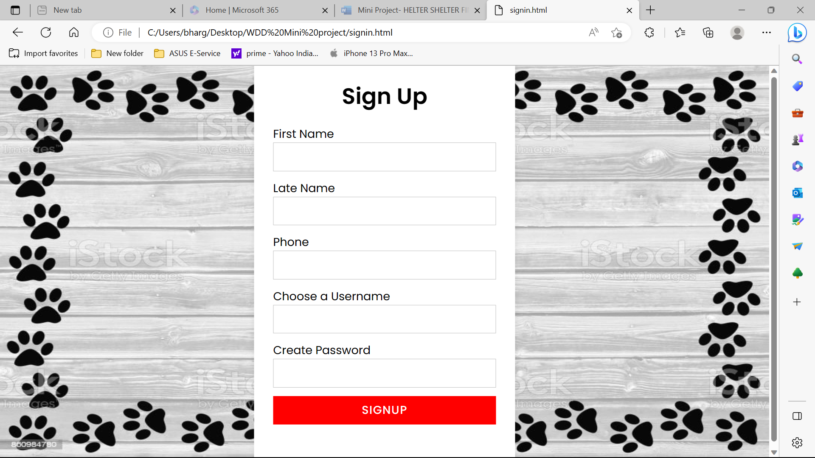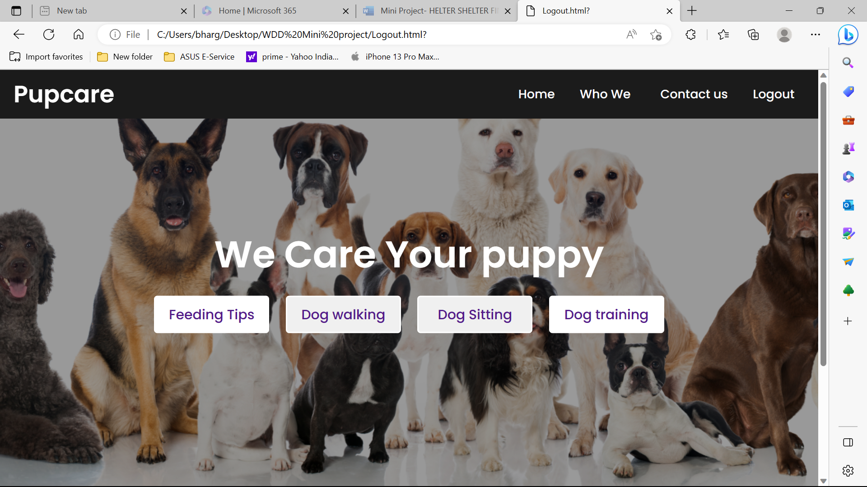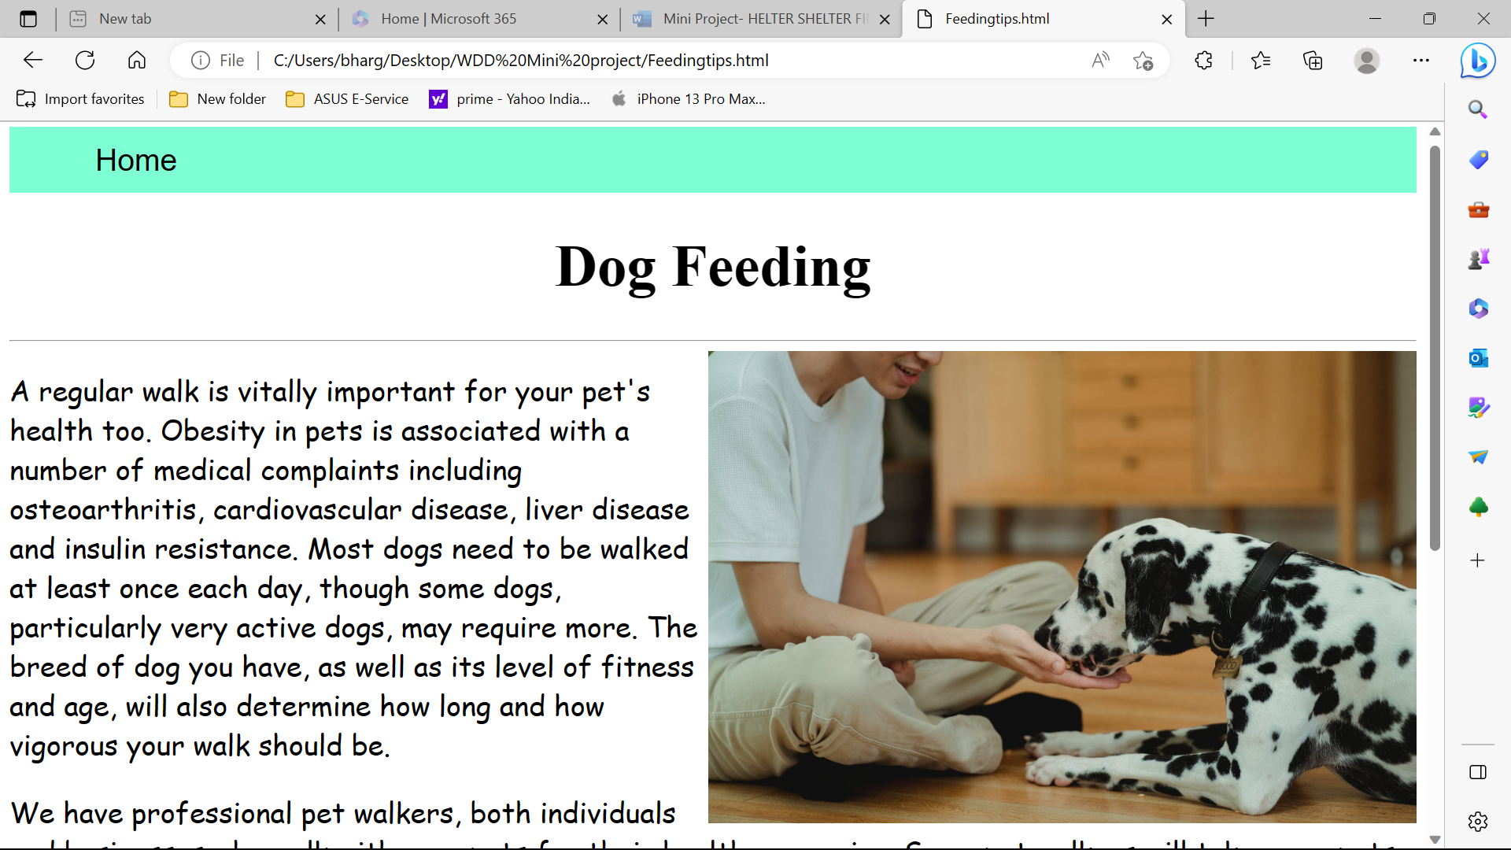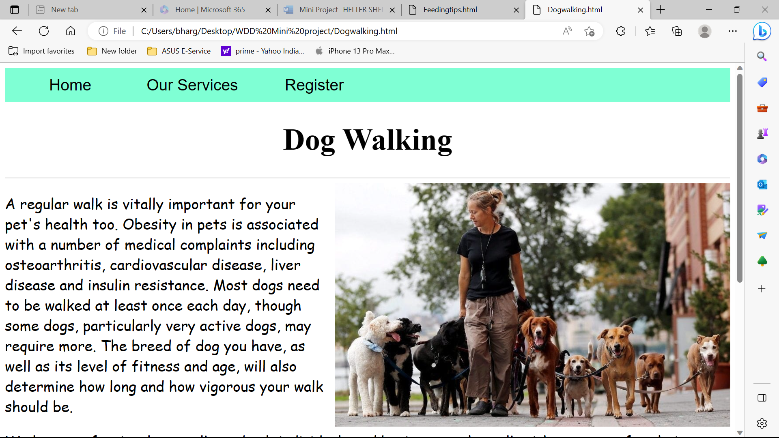

**CHAPTER 4**

**WEB SITE BACK-END IMPLEMENTATION**

**4.1 Tools used**

Programming languages: Python. PHP JavaScript. Ruby Java, C#

Frameworks: Laravel. Django. Spring. Ruby on Rails. Meteor. Node.js.

Databases: MongoDB. MySQL Oracle.

Servers: Apache. NGINX. Lighttpd. Microsoft IIS.

**4.2 Code for Back-end**

import pandas as pd

import numpy as np

from sklearn.metrics.pairwise import cosine_similarity

# load data

courses_data = pd.read_csv('courses.csv')

# calculate item-item similarity matrix

courses_data_features = courses_data.iloc[:, 2:]

cosine_similarities = cosine_similarity(courses_data_features)

# get top recommended courses for a given course

def get_recommendations(course_id, top_n=5):

index = courses_data[courses_data['course_id'] == course_id].index[0]

similarity_scores = list(enumerate(cosine_similarities[index]))

similarity_scores = sorted(similarity_scores, key=lambda x: x[1], reverse=True)

top_courses_indices = [i[0] for i in similarity_scores[1:top_n+1]]

return courses_data.iloc[top_courses_indices, :]

25

# example usage

recommendations = get_recommendations('CSE101', top_n=3)

print(recommendations)

?>



**CHAPTER 5**

**DATABASE DESIGN**

**5.1 Database used**

PHP is a popular server-side scripting language that is commonly used to build dynamic websites and web applications. One of the key features of PHP is its ability to interact with databases, allowing developers to create powerful and scalable applications.A database is a collection of data that is organized and stored in a way that allows for easy retrieval and manipulation. PHP can be used to connect to various types of databases, including MySQL, PostgreSQL, Oracle, and Microsoft SQL Server. Once connected to a database, PHP can be used to perform a wide range of operations, such as creating and updating tables, inserting and retrieving data, and executing complex queries. PHP also provides a variety of built-in functions and libraries for working with databases, making it easier to write efficient and secure database-driven applications. Overall, PHP is a powerful tool for building database-driven web applications. Its ability to interact with databases allows developers to create applications that are robust, scalable, and easy to maintain, making it a popular choice for building a wide range of web applications, from simple blogs to complex e-commerce platforms.

**5.2 Database schema and Tables**

In PHP, a database schema refers to the structure or blueprint of a database, which includes tables, fields, and relationships between tables. A database schema defines the rules for how data is stored, organized, and accessed in a database. When working with databases in PHP, developers typically use a database management system (DBMS) such as MySQL, PostgreSQL, or Microsoft SQL Server. The DBMS provides tools and interfaces for creating and managing database schemas, as well as performing various database operations such as inserting, updating, and retrieving data. To create a database schema in PHP, the first step is to connect to the database using a database driver such as mysql or PDO. Once connected, developers can use SQL commands to create tables, define fields, and specify relationships between tables. For example, the following SQL command creates a simple users table in MySQL:

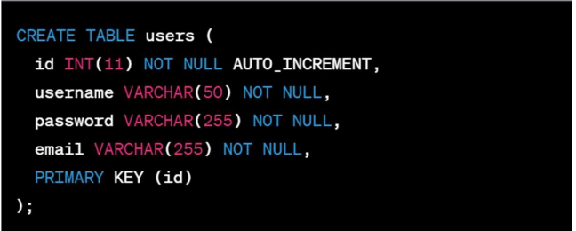

This command creates a table called "users" with three fields: id, username, and email. The id field is set as the primary key, which means it uniquely identifies each row in the table. Once the schema is created, PHP can be used to interact with the database and perform various operations such as inserting, updating, and retrieving data. For example, the following PHP code inserts a new user into the user’s table:

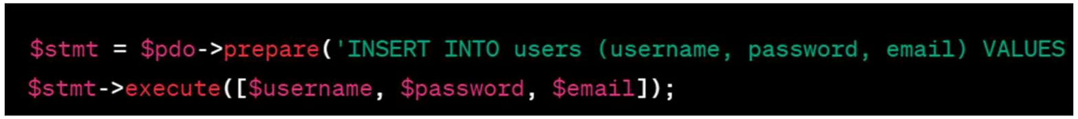**5.3 Database Connectivity**

To connect to a database using PHP, you can use the following steps:

1. Choose a database management system (DBMS) that you want to use with PHP, such as MySQL or PostgreSQL.

2. Install the required PHP extensions for the chosen DBMS. For example, for MySQL, you need to install the mysqli extension or PDO_MySQL extension.

3. Open a PHP script file and add the following code at the beginning to create a database connection:

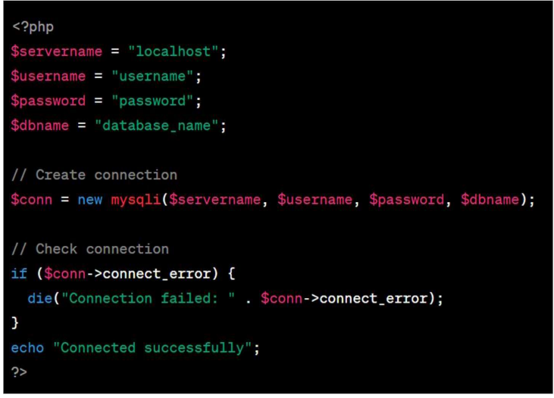

**CHAPTER 6**

**WEB HOSTING IN CLOUD**

Hosting a website on Amazon S3 is a simple and cost-effective way to serve static websites that require high availability and scalability. Here's how to host a website on AWS S3:

1. Create an S3 bucket - In the AWS Management Console, navigate to the S3 service, and create a new bucket. The bucket name must be unique and should match your domain name. For example, if your domain name is example.com, your bucket name should be

"example.com."

2. Enable static website hosting - In the Properties tab of your S3 bucket, select "Static website hosting." Choose the "Use this bucket to host a website" option and enter the index document name (e.g., index.html) and optionally the error document name (e.g., error.html).

3. Upload your website content - Using the AWS Management Console, the AWS CLI or an SDK, upload your website content (HTML, CSS, JavaScript, images, etc.) to your S3 bucket. Ensure that your index file is located at the root of your bucket or in the path specified as the index document name.

4. Configure bucket permissions - In the Permissions tab of your S3 bucket, click on "Bucket Policy." Enter the following policy statement to allow public access to your bucket:

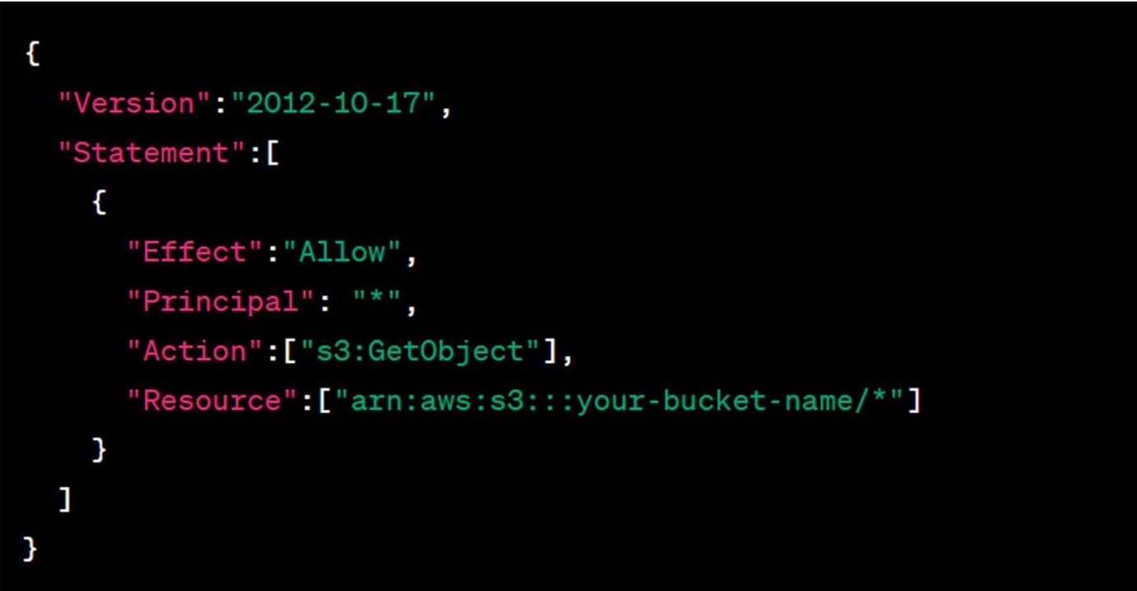

Replace "your-bucket-name" with the actual name of your S3 bucket.

5. Create a DNS record - In your DNS management console, create a CNAME record that maps your domain name to the endpoint of your S3 bucket. The endpoint can be found in the Properties tab of your bucket under "Static website hosting."

6. Test your website - Once your DNS record has propagated; you can test your website by navigating to your domain name in a web browser.

AWS S3: (HTTPS://AWS.AMAZON.COM/S3/)

Amazon S3 (Simple Storage Service) is a cloud-based object storage service provided by Amazon Web Services (AWS). It provides a simple and scalable way to store, retrieve, and manage data in the cloud.

Here are some key features of AWS S3:

Scalability and Availability: S3 is designed to provide high availability and scalability. It automatically scales to meet demand and provides durable storage across multiple Availability Zones.

Security: S3 provides multiple security features, including encryption in transit and at rest, access control, and audit logging.

Cost-effective: S3 provides a pay-as-you-go pricing model, allowing you to pay only for the storage you use. There are no upfront costs or long-term commitments.

Object Storage: S3 is designed for storing and managing large amounts of unstructured data, such as images, videos, documents, and backups.

**CHAPTER 7**

**SCREEN SHOTS**

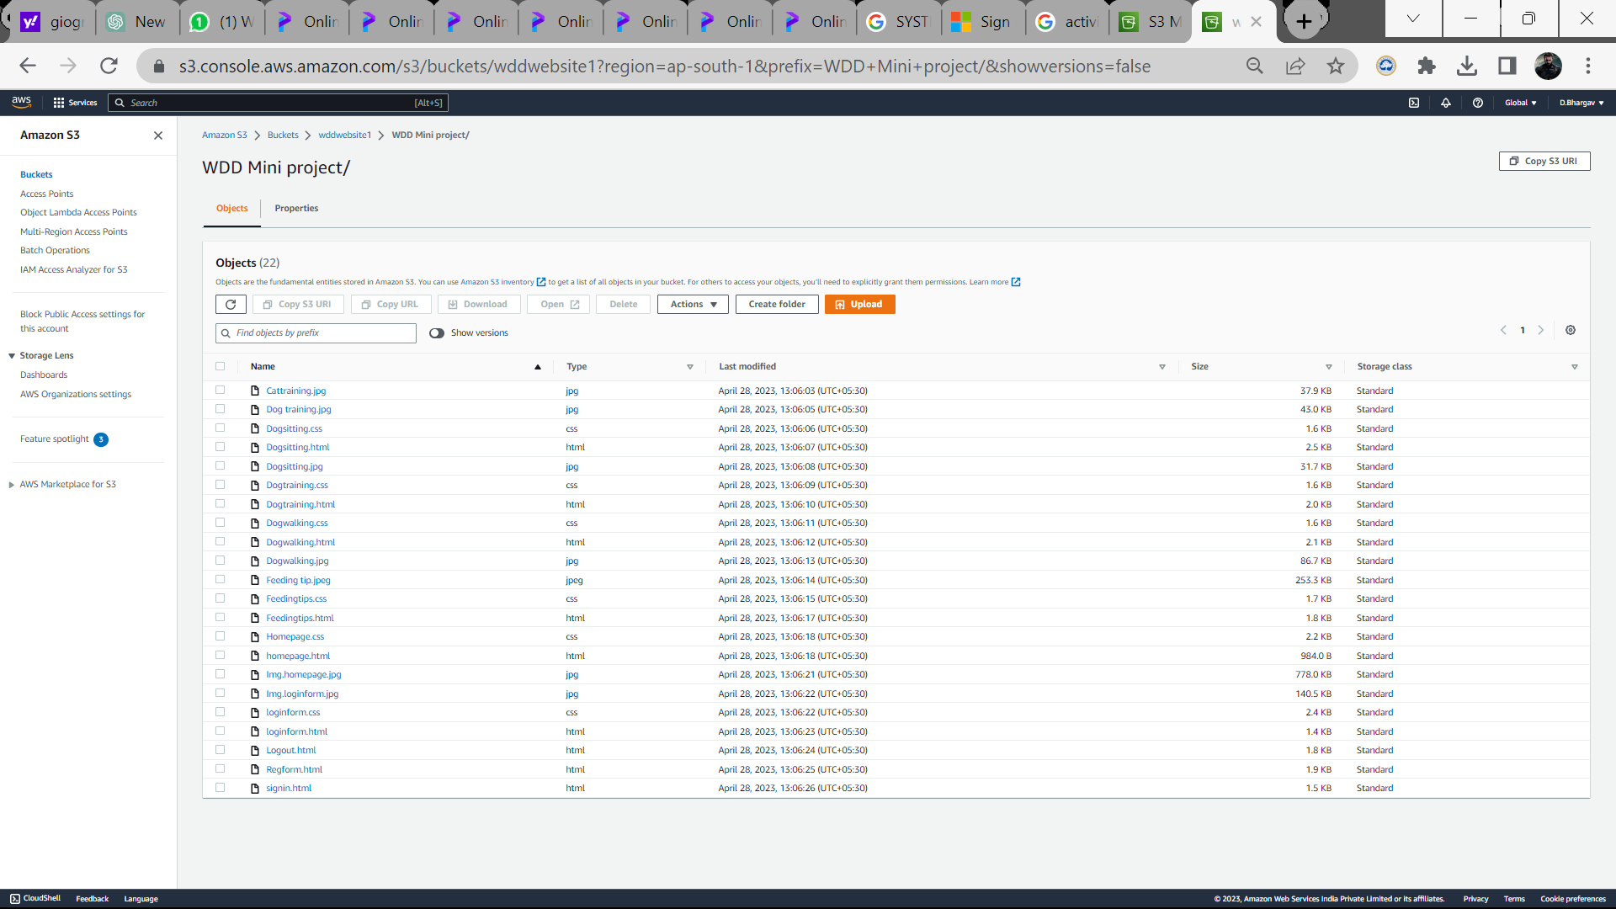

**CHAPTER 8**

**CONCLUSION AND FUTURE WORK**

**CONCLUSION**

In conclusion, OUR web page is an excellent resource for pet owners and pet service providers to connect and share information. The back-end code provided in this example demonstrates how to create a simple database schema and API endpoints to manage pets and their owners. It helps to improve the health of a dog and make it happy and enjoy its best the service will be lovable

Overall, a pet care web page has a lot of potential for growth and expansion, and there are many ways to make it more useful and valuable for pet owners and pet service providers.

**FUTURE WORK:**

Adding authentication and authorization to ensure only authorized users can access sensitive information.

Integrating with third-party services such as payment gateways or social media platforms to provide a more comprehensive user experience.

Implementing additional features such as appointment scheduling, pet health tracking, and pet adoption services.

Improving the user interface and experience to make the website more appealing and user-friendly.

Incorporating machine learning and artificial intelligence algorithms to provide personalized recommendations for pet care based on pet and owner data.

**References**

Rover.com: This website connects pet owners with local pet sitters and dog walkers

Petco.com: This website is an online pet store that offers a wide range of pet products and services.

Chewy.com: This website is another popular online pet store that offers a wide selection of pet products and fast delivery.

PetMD.com: This website provides a wealth of information about pet health and wellness, including articles, videos, and forums.

ASPCA.org: This website is the official website of the American Society for the Prevention of Cruelty to Animals (ASPCA) and provides information on pet adoption, animal welfare, and animal cruelty prevention.

Petfinder.com: This website helps connect people with adoptable pets in their local area.

Canna-Pet.com: This website offers CBD products for pets to help with a variety of ailments.

**AWS hosted link:**

https://s3.console.aws.amazon.com/s3/buckets/wddwebsite1?region=ap-south-1&prefix=WDD+Mini+project/&showversions=false